4CS015 – Workshop #5
Name: Nayan Raj Khanal
Student ID: 2227486
Workshop tasks:
Arithmetic Logic Unit:
Load the LogSim Arithmetic Logic Unit Circuit alu.cct from inside the logsim application (You'll find it in the logsim folder) (You may need to right-click on the link to download the file instead of opening it in the browser). It should look like this:
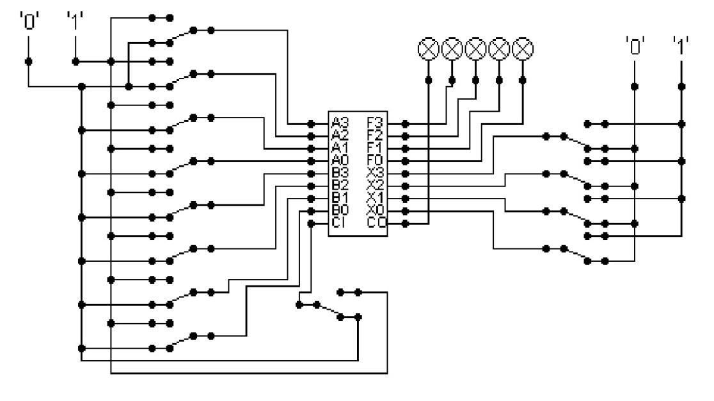
The circuit behaves like a simple arithmetic logic unit. The inputs A0-A3 represent a 4-bit binary number. Inputs B0-B3 represent another binary number. A0 and B0 are the least significant bits respectively. The following table details the functions supported by the chip. All other control lines = 0.
Function | AND | OR | XOR | NAND | NOR | NOT A | ADD | SUBTRACT
X3 – X0 | 0000 | 0001 | 0010 | 0011 | 0100 | 0101 | 1010 | 1011

Use A= 15 B=12, complete the following table in binary (15 marks):
FUNCTION | OUTPUT
AND | 01100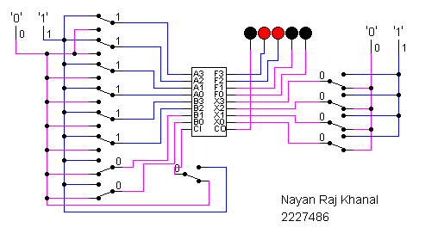
OR | `01111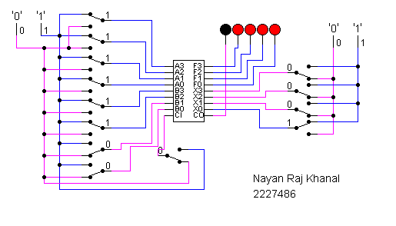
XOR | 00011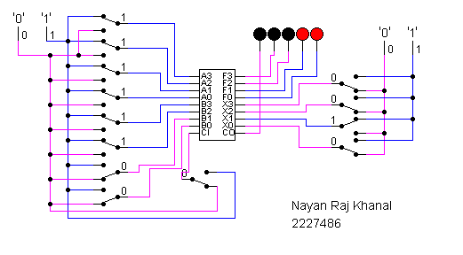
NAND | 00011  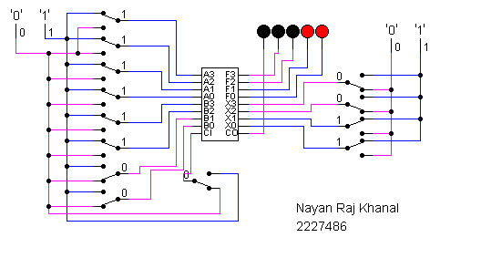
NOR | 00000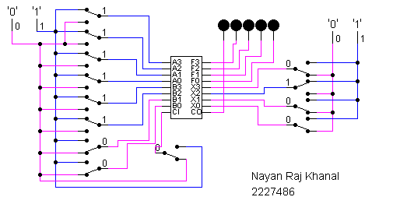
NOT A | 00000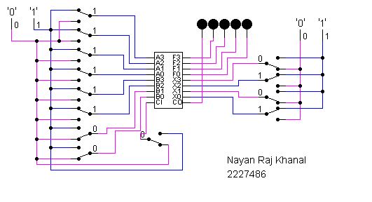
ADD | 11011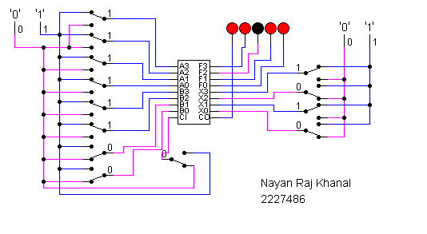
SUBTRACT | 00011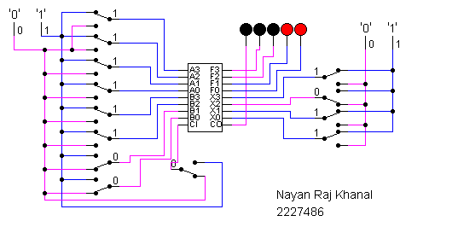

The logical operations are bitwise. Manually prove each operation has returned the correct result by (15 marks):
Example: 1 0 1 1
1 0 1 0 AND OPERATION
1 0 1 0 RESULT
1 1 1 1 1 1 1 1 1 1 1 1 1 1 1 1
1 1 0 0 AND 1 1 0 0 OR 1 1 0 0 XOR 1 1 0 0 NAND
1 1 0 0 RESULT 1 1 1 1 RESULT 0 0 1 1 RESULT 0 0 1 1 RESULT

1 1 1 1 1 1 1 1 1 1 1 1 1 1 1 1
1 1 0 0 NOR 1 1 0 0 NOT A 1 1 0 0 ADD 1 1 0 0 SUB
0 0 0 0 RESULT 0 0 0 0 RESULT 1 1 0 1 1 RESULT 0 0 1 1 RESULT

Serial to Parallel Decoder (30 marks):
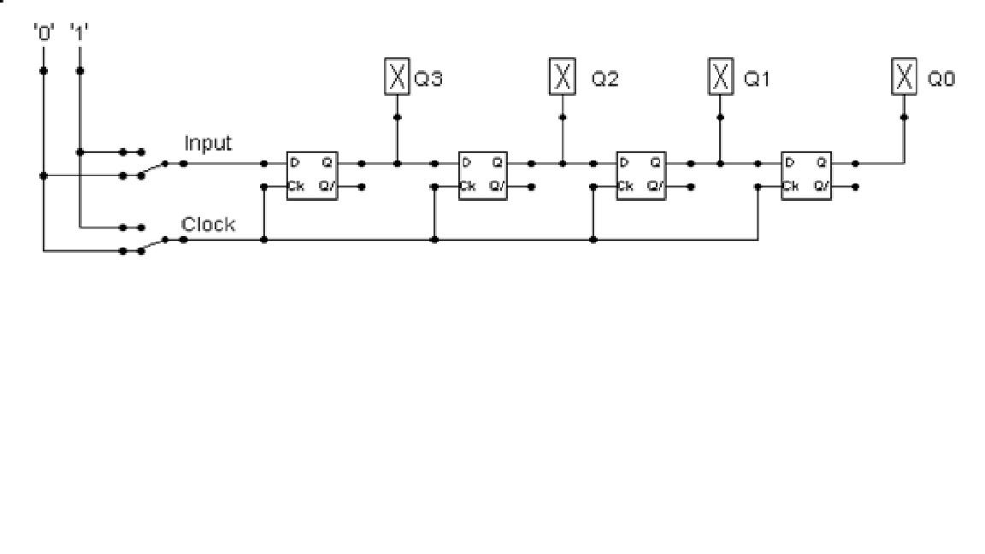
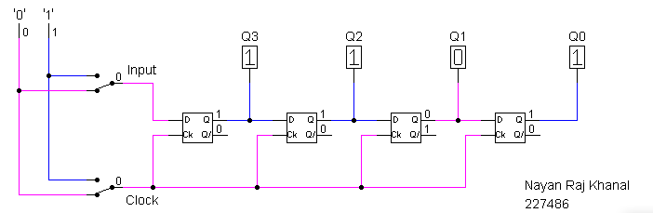
Build the circuit above and complete the following timing diagram by filling in the table spaces with ‘1’ or ‘0’. (15 marks)
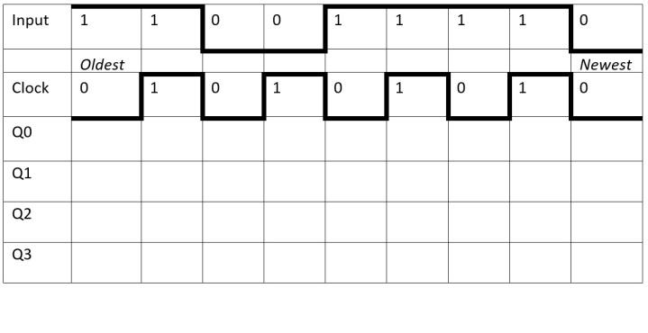
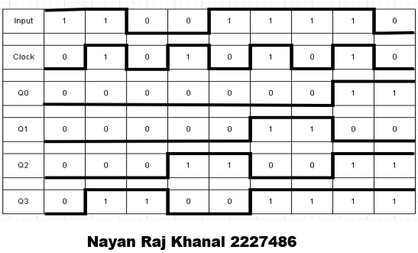
Describe what the circuit does. (15 marks)
The following diagram shows serial and parallel inputs and outputs respectively. The outputs being Q0, Q1, Q2, and Q3. Also, four D-flips flops are included in the diagram. The input is only passed on each rising edge of the clock, that is, when it goes from '0' to '1'. At first, all of the values will be zero. After that input 1 is passed, resulting the clock to be set to zero. As the clock is at zero, the input value is not passed, making all outputs are set to zero. Likewise, when the input is 1, the clock is 1 as well, and now the input is transferred to Q3. Only when the clock value is 1, the input is taken and the received input is passed to the right causing shifting. This results in the output of the previous value becoming the input to the next.
Parallel to Serial converter
Open the LogSim circuit week5.cct from the Logsim folder. It should look like this:
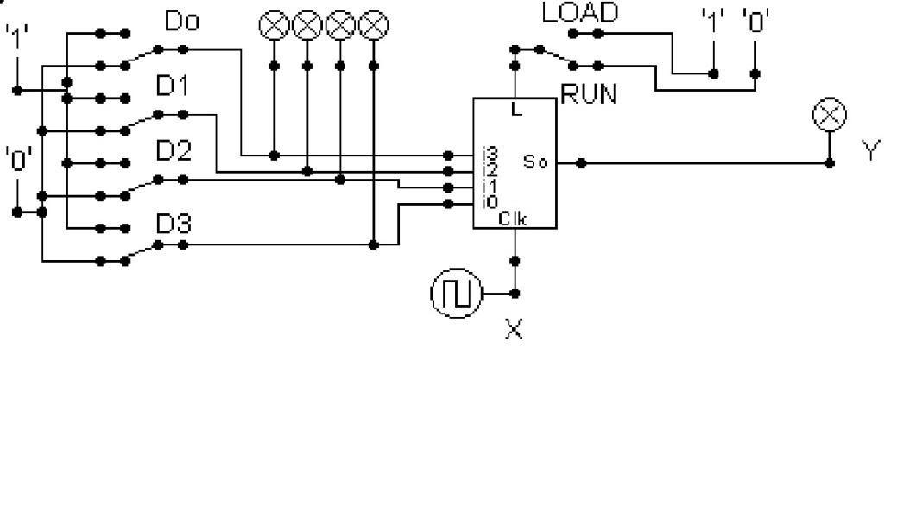
Describe what this circuit does. (15 marks)
The diagram above depicts parallel and serial input and output. D0, D1, D2 and D3 are the available inputs. By placing the inputs in D0-D3 load gets enabled which then as the term suggests loads the provided input into the shift register. It works during the rising edge of the clock that is only when the clock X has the value of 1, the output is serially presented in Y after the input is loaded.

Design and add to the above circuit an additional circuit that takes the Clock X and the Output Y and decodes Y into 4 output indicators so that they match D0 – D3. Insert the LogSim GIF output of your design in the space below.
The highest marks will go to those who design the circuit such that it AUTOMATICALLY stops (not pauses) when the input to the circuit matches the output to the circuit
Note: Save your GIF image when your output indicators match the input D0 - D3. (35 marks)
